I. Class in the U.S.

A. Problem: Plutocracy and the economy.

1. How much inequality can a consumer economy have and still function

for the majority?

2. Can a democracy really be “of the people” with extreme inequality?

3. What is the relationship between economic inequality and power?

a. economic power

b. political power

c. ideological power

4. Power and vital needs?

B. Wealth: what is wealth?

1. Net worth: what you own minus what you owe

2. Financial wealth: easily converted to cash or income producing

( stocks, bonds, trusts, business equity, financial securities, commercial property)

3. In terms of power: owning the means of production

4. 2017 $96 trillion

a. 3 Americans more than bottom 50%

b. Wealthiest 400 more than bottom 64%

C. Net Worth by household

1. Top .01%

a. 22% of all wealth ^^^ (avg $43 million)

b. Walton Family (6) have more wealth than 40% of American Families combined ($102.7 billion)

c. wealthiest 15 people +$170,000,000,000 in last two years

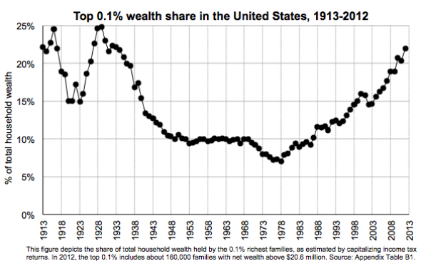

[Saez and Zucman, 2014](http://www.nber.org/papers/w20625.pdf)

<https://www.theguardian.com/business/2014/nov/13/us-wealth-inequality-top-01-worth-as-much-as-the-bottom-90>

2. Top 1% = 35/$10.4 million

3. Top 20% = 89% (80% of the population has 11% of the wealth--- US)

4. median family $ 97,300 (-30% from 2007)

5. race: W $171,00, Hispanic $20,700, Black $17,600 (1 in 5 zero)

<https://www.epi.org/blog/the-racial-wealth-gap-how-african-americans-have-been-shortchanged-out-of-the-materials-to-build-wealth/>

6. Top 1% $33.4 trillion v bottom 1% -$196 billion

<http://www.census.gov/people/wealth/files/Wealth%20distribution%202000%20to%202011.pdf>

D. Financial wealth

1. Top .01%=27%

2. Top 1% = 42%

3. Top 10% = 85%

(Stocks, bonds, trusts, business equity, financial securities)

3. Bottom 80%=5%, Bottom 50% 0.8%

“When the business news reports that the economy is booming and the stock market is at a record high, that means absolutely nothing for the lives of the majority of Americans, except that more jobs were automated and outsourced, benefits were reduced, and more tax breaks were given to the rich and corporations.”

E. Trend

1. top .01% 3x since 1970s, top 1% 2x
2. Forbes 400 $5.7 trillion (+$3.2 trillion since 2004)

In 1982 13 billionaires on the list, but in 2017 169 billionaires can’t make the list.

3. Bottom 90% since 1970s -14%

F. Comparison

1. Industrial countries: 23 out of 30, last in income and wealth distribution and highest in per cent in poverty (World Economic Forum)

2. 4th highest degree of wealth inequality out of 141 countries (Global Wealth Report)

3. Historically

3. Race: White >13xAA, 10x Hispanics

<http://www.pewresearch.org/fact-tank/2014/12/12/racial-wealth-gaps-great-recession/>

Wealth Inequality in the U.S.

<http://www.youtube.com/watch?v=QPKKQnijnsM>

II. Inequality by Income

A. Income

1. Investment income (from financial wealth)

2. Income from work taxed at a higher rate than investment income

3. Real income

B. Income by % and/or avg

1. top .001 (minimum income $62.1 million/avg tax rate 17.6%!)

1. top .01%: $27, 342, 212 (15,000 households, > bottom 150 million)

2. top 1% : 23% /$1,137,684

3. median household: $59, 039

4.bottom 40% avg $17,300

5. median race W $61,200, H $38,500, B $35,400

<https://research.stlouisfed.org/fred2/series/MEHOINUSA672N>

C. Source of income

1. top 10% receive 80% of investment income

2. dividends, interest, rent, capital gains

D. Trend

1. top 1% last 30 years 2x share of income (CBO)

2. “economic recovery” top 1% 93% of all income growth

<http://www.truthdig.com/report/item/as_wealthy_surge_us_poor_and_middle_class_incomes_20160512>

E. Comparison

1.world: 93rd between Mexico and Iran.

2.historically

Nine charts

<http://apps.urban.org/features/wealth-inequality-charts/>

F. Corporations

1. 2001 $503 billion 2008 $1.35 trillion

2. ALL TIME RECORD 2010 $1.68 TRILLION

3. Cash on hand $2 trillion (largest in over fifty years)

4. Fortune 500 2011 all time record $824 billion

1. “Overseas”

Last Week Tonight: Inequality

<https://www.youtube.com/watch?v=LfgSEwjAeno>